Potential of domestic biomass resources for the energy transition in Switzerland
O. Thees, V. Burg, M. Erni, G. Bowman, R. Lemm

General supply costs for primary energy biomass in Switzerland
Figure 1 shows the wide range in the costs of mobilizing the different resources to produce energy. The figures refer to the sustainable potential of woody and non-woody types of biomass, and indicate how much energy is available for each type of biomass and how much it would cost to supply the biomass to the energy facility. They show clearly that it is mostly more expensive to use the woody than the non-woody types of biomass, and that the price rises with increasing exploitation of the resources. Partial quantities of individual biomasses are available at different costs, mostly because of their supply costs. This applies to hardwood from the forest, for example. With household waste and part of the industrial wood residues, the costs are negative because collecting them incurs charges.
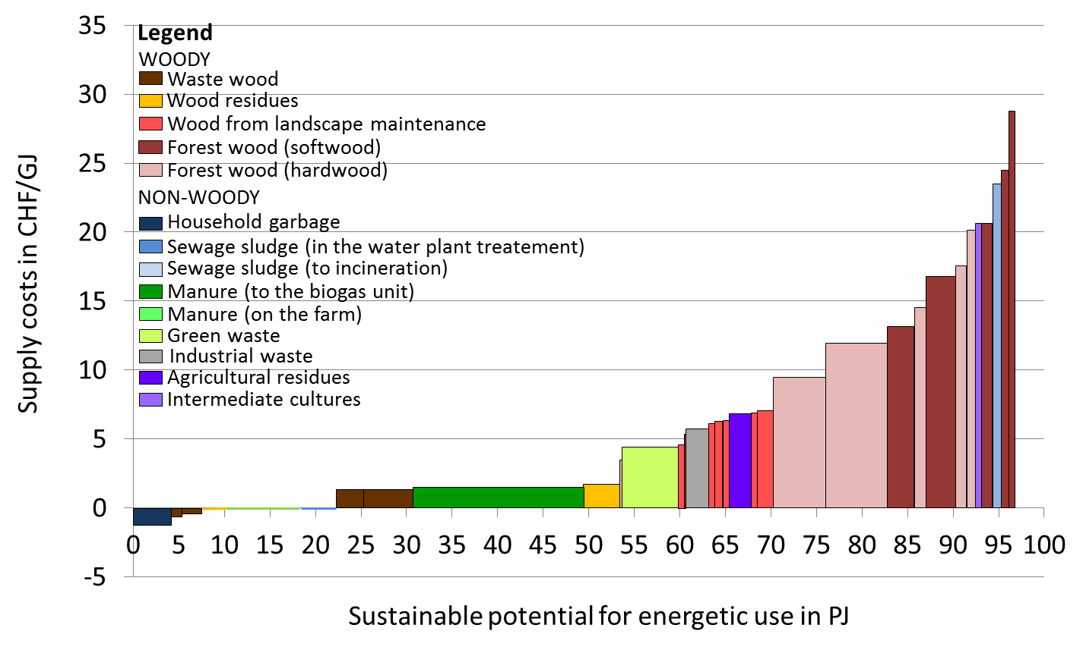
Figure 1: Cost of using the sustainable primary energy potential of all 10 biomass types in Swiss francs per Gigajoule.

